**Lab 11: Android Themes**

# **Introduction**

Theme is an Android App Style which is applied to entire screen components not individual view.

* On applying a theme each view which belongs to that category will consume that style and converts itself.
* To apply a theme in an Android app, an attribute named android:theme need to configured

**Let’s get Started**

The activity that follows shows how to apply a theme to an application. We will alter our standard AppTheme for demonstration purposes, changing the default text's size, font family, shadow effects, etc.

**Step 1: Create a New Project in Android Studio as shown below**

**Step 2: Select Empty Activity as shown below**

**Step 3: Provide a Project Name as shown below**

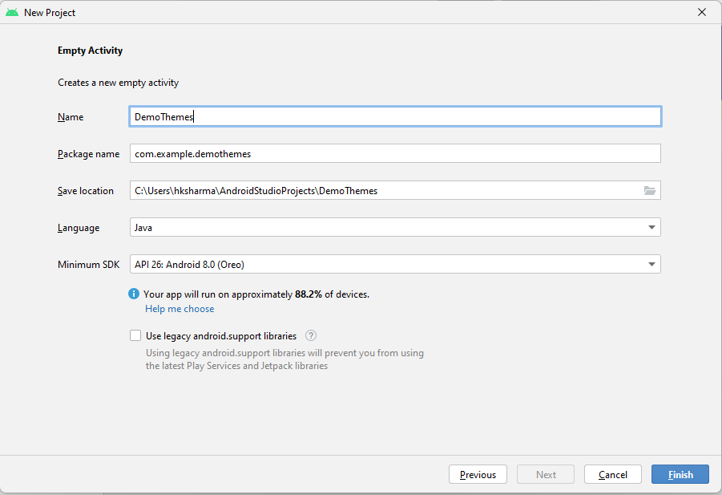

**Step 4: Update MainActivity.java as per the code given below**

**package** com.example.demoStyle;  
**import** androidx.appcompat.app.AppCompatActivity;  
**import** android.os.Bundle;  
**public class** MainActivity **extends** AppCompatActivity {  
  
 @Override  
 **protected void** onCreate(Bundle savedInstanceState) {  
 **super**.onCreate(savedInstanceState);  
 setContentView(R.layout.***activity_main***);  
 }  
}

**Step 5: Create a new xml file style.xml in res/values folder and write the code given below**

*<?***xml version="1.0" encoding="utf-8"***?>*<**resources**>  
 <**style name="ThemeGreen" parent="Theme.AppCompat.Light"**>  
 <**item name="android:windowBackground"**>#50E619</**item**>  
 <**item name="android:colorBackground"**>#68E619</**item**>  
 <**item name="colorPrimary"**>#4FFF3B</**item**>  
 <**item name="android:textColorPrimary"**>#FA1804</**item**>  
 <**item name="colorPrimaryDark"**>#F10707</**item**>  
 </**style**>  
  
 <**style name="ThemeRed" parent="Theme.AppCompat.Light"**>  
 <**item name="android:windowBackground"**>#E64A19</**item**>  
 <**item name="android:colorBackground"**>#D32F2F</**item**>  
 <**item name="colorPrimary"**>#4FFF3B</**item**>  
 <**item name="android:textColorPrimary"**>#FA1804</**item**>  
 <**item name="colorPrimaryDark"**>#F10707</**item**>  
 </**style**>  
</**resources**>

**Step 6: Update activity_main.xml as per the code given below**

*<?***xml version="1.0" encoding="utf-8"***?>*<**LinearLayout  
 xmlns:android="http://schemas.android.com/apk/res/android"  
 xmlns:app="http://schemas.android.com/apk/res-auto"  
 xmlns:tools="http://schemas.android.com/tools"  
 android:layout_width="match_parent"  
 android:layout_height="match_parent"  
 android:orientation="vertical"  
 tools:context=".MainActivity"**>  
 <**Button  
 style="@style/btnStyle"  
 android:text="Android"**/>  
 <**Button  
 style="@style/btnStyle"  
 android:text="Windows"**/>  
 <**Button  
 style="@style/btnStyle"  
 android:text="iPhone"**/>  
 <**Button  
 style="@style/btnStyle"  
 android:text="Blackberry"**/>  
 <**Button  
 style="@style/btnStyle"  
 android:text="Nokia"**/>  
</**LinearLayout**>

**Step 7: Update AndroidManisfest.xml as per the code given below**

*<?***xml version="1.0" encoding="utf-8"***?>*<**manifest xmlns:android="http://schemas.android.com/apk/res/android"  
 xmlns:tools="http://schemas.android.com/tools"**>  
  
 <**application  
 android:allowBackup="true"  
 android:dataExtractionRules="@xml/data_extraction_rules"  
 android:fullBackupContent="@xml/backup_rules"  
 android:icon="@mipmap/ic_launcher"  
 android:label="@string/app_name"  
 android:roundIcon="@mipmap/ic_launcher_round"  
 android:supportsRtl="true"  
 android:theme="@style/Theme.DemoTheme"  
 tools:targetApi="31"**>  
 <**activity  
 android:name=".MainActivity"  
 android:exported="true"  
 android:theme="@style/ThemeRed"**>  
 <**intent-filter**>  
 <**action android:name="android.intent.action.MAIN"** />  
  
 <**category android:name="android.intent.category.LAUNCHER"** />  
 </**intent-filter**>  
  
 <**meta-data  
 android:name="android.app.lib_name"  
 android:value=""** />  
 </**activity**>  
 </**application**>  
  
</**manifest**>

**Step 8: Check Output on Android Emulator.**

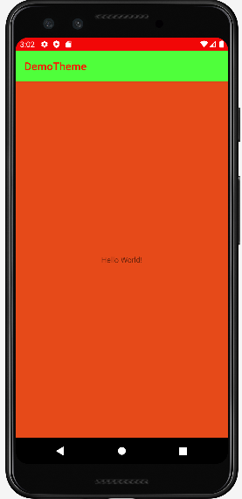

**Step 9: Update AndroidManisfest.xml as per the code given below**

*<?***xml version="1.0" encoding="utf-8"***?>*<**manifest xmlns:android="http://schemas.android.com/apk/res/android"  
 xmlns:tools="http://schemas.android.com/tools"**>  
  
 <**application  
 android:allowBackup="true"  
 android:dataExtractionRules="@xml/data_extraction_rules"  
 android:fullBackupContent="@xml/backup_rules"  
 android:icon="@mipmap/ic_launcher"  
 android:label="@string/app_name"  
 android:roundIcon="@mipmap/ic_launcher_round"  
 android:supportsRtl="true"  
 android:theme="@style/Theme.DemoTheme"  
 tools:targetApi="31"**>  
 <**activity  
 android:name=".MainActivity"  
 android:exported="true"  
 android:theme="@style/ThemeGreen"**>  
 <**intent-filter**>  
 <**action android:name="android.intent.action.MAIN"** />  
  
 <**category android:name="android.intent.category.LAUNCHER"** />  
 </**intent-filter**>  
  
 <**meta-data  
 android:name="android.app.lib_name"  
 android:value=""** />  
 </**activity**>  
 </**application**>  
  
</**manifest**>

**Step 9: Check Output on Android Emulator.**

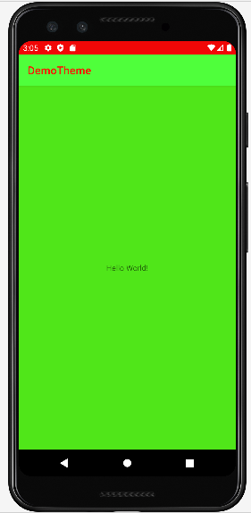

**Voila!!** We have successfully completed this lab.